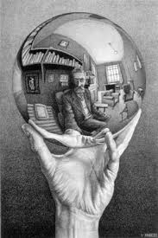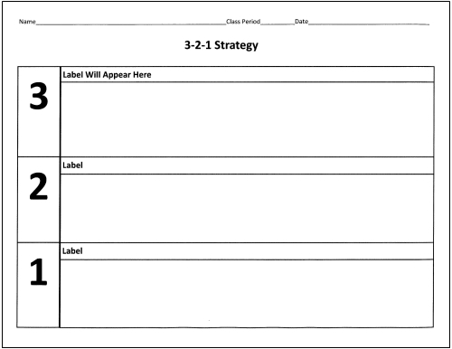

**Synthesis**: How can I take what I’ve learned and make an even better impression on my employer/employees?

**Application**: What did I hear the employers say would make for a strong interview? What needs do employees have?

**Reflection**: What were my strengths & weaknesses? What were the strengths and weaknesses of my applicants?