

**573-346-9260 ext. 7375 atynes@camdentonschools.org**

**www.mrstynes.weebly.com 123 Main St., Eldon, MO 65026**

Angela Tynes

Teacher ~ Instructional Coach

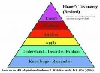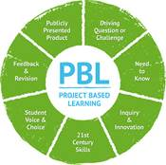

**Interesting Facts**

Provide additional information that may make you stand out, show your experiences using your hobbies or travels, or show your personality, your volunteer experiences, or your passions that may influence your work in a positive way.

**Work Experience**

List your current job (employer) starting with beginning and ending dates. Include your job title and what you did to make an impact in this company. Line up your jobs with the number of years you spent there.

**Education**

Start with the years you attended your most recent school: technical school, college, or high school. Include the name of this school followed by the training you received there. Include the degree, certificate, or diploma you earned.

**Special Training**

List the skills you have obtained while at LCTC, in a work-based learning experience (clinicals, observations, job shadowing, internship, etc.), high school, or college. Rate your proficiency at each skill out of 1 using a series of filled/unfilled dots.

**Awards and Honors**

**My Specialties**

Which programs, software, or tools are you trained in using for the job you are applying? Find icons from Google Images, save, insert, format the icon as wrap text: square, resize, and give a brief explanation.



**“All around creative”**

What do people say about you? Quote them and then explain how this will benefit the organization you want to work for.



**573-346-9260 ext. 7375 atynes@camdentonschools.org**

**www.mrstynes.weebly.com 123 Main St., Eldon, MO 65026**

Angela Tynes

Teacher ~ Instructional Coach

**(phone)**

**references**