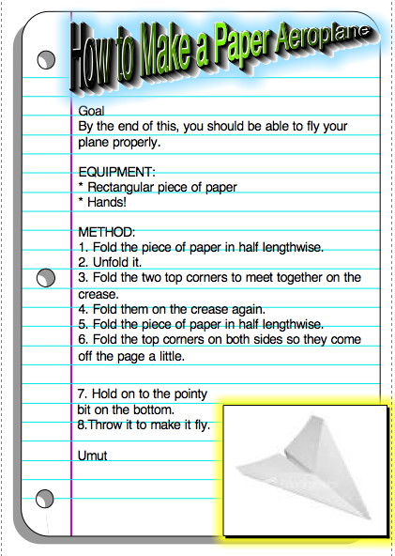

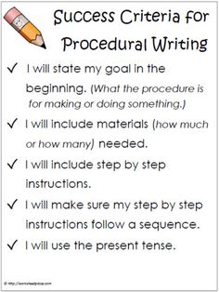

Turn in the final draft of both procedural writing documents using the guidelines listed here. **Save these documents** so that you can use them again for your ePortfolio.

Next time, we will begin working on resumes. From there, we will begin your ePortfolio site.

